React Js Notes

Create a folder using your command prompt and name it as per your wish such as **Example:ReactProjectTest.**

And the next process after creating a folder is to execute few commands such that it can able to create few default files and those commands are listed below

npm init -y

npm install react --save

npm install react-dom --save

npm install webpack --save

npm install webpack-dev-server --save

npm install webpack-cli --save​

npm install babel-core --save-dev

npm install babel-loader --save-dev

​npm install babel-preset-env --save-dev

npm install babel-preset-react --save-dev

npm install html-webpack-plugin --save-dev

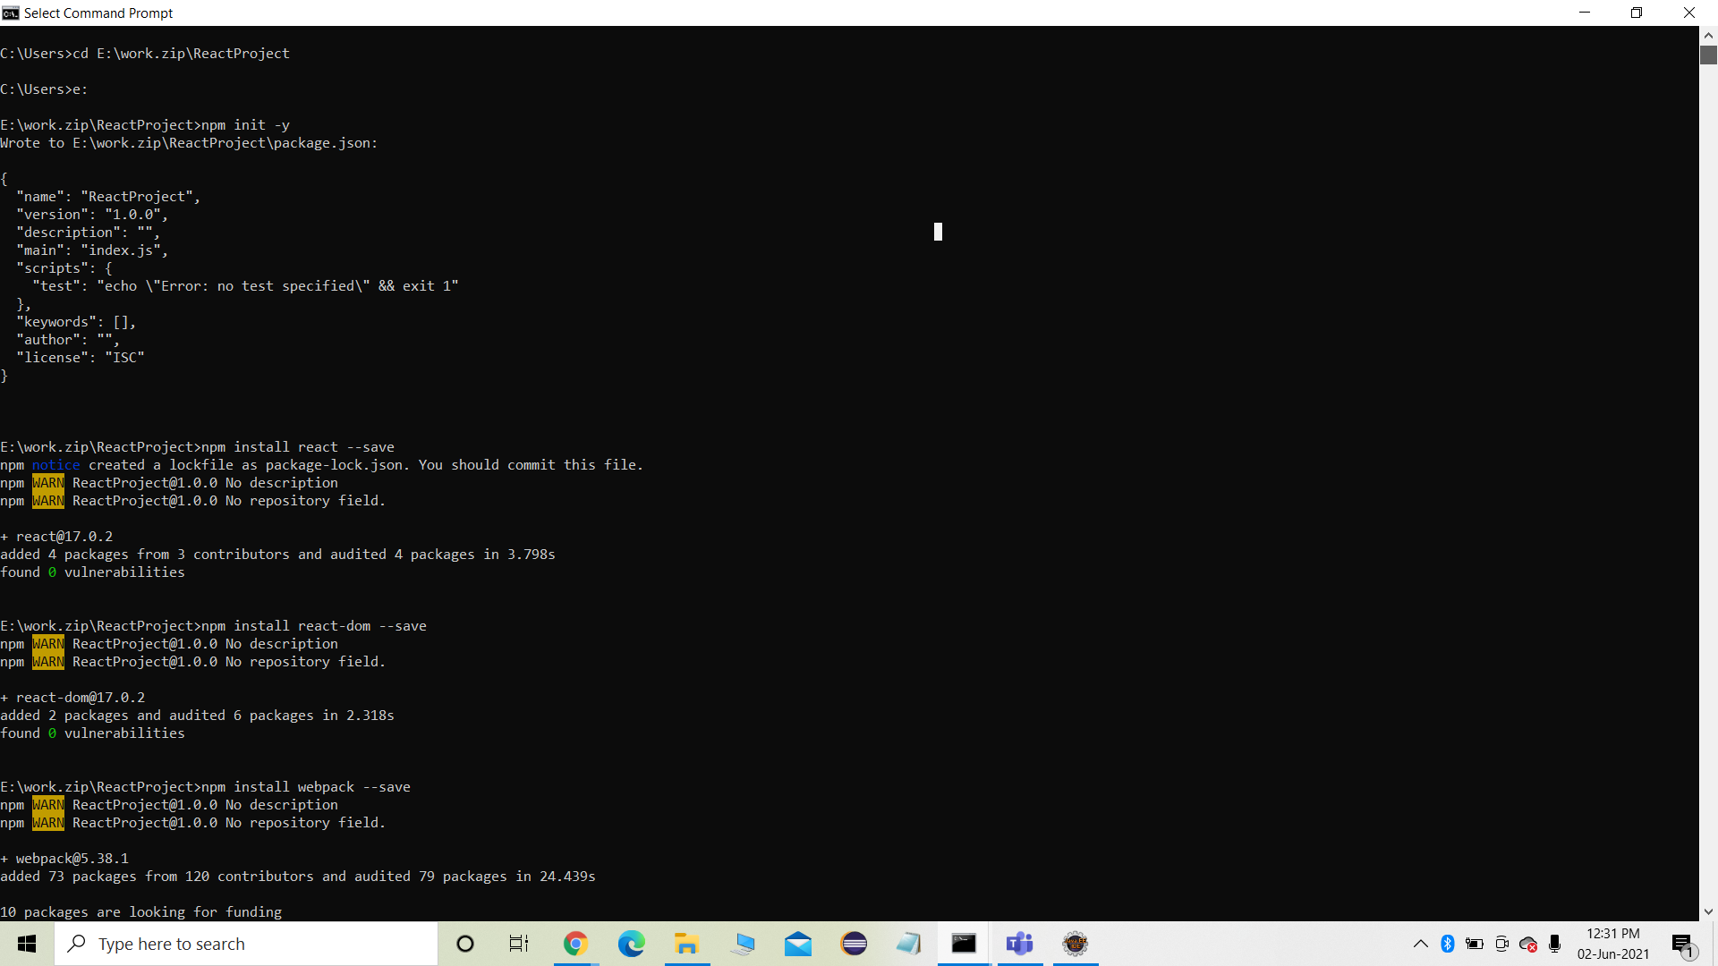

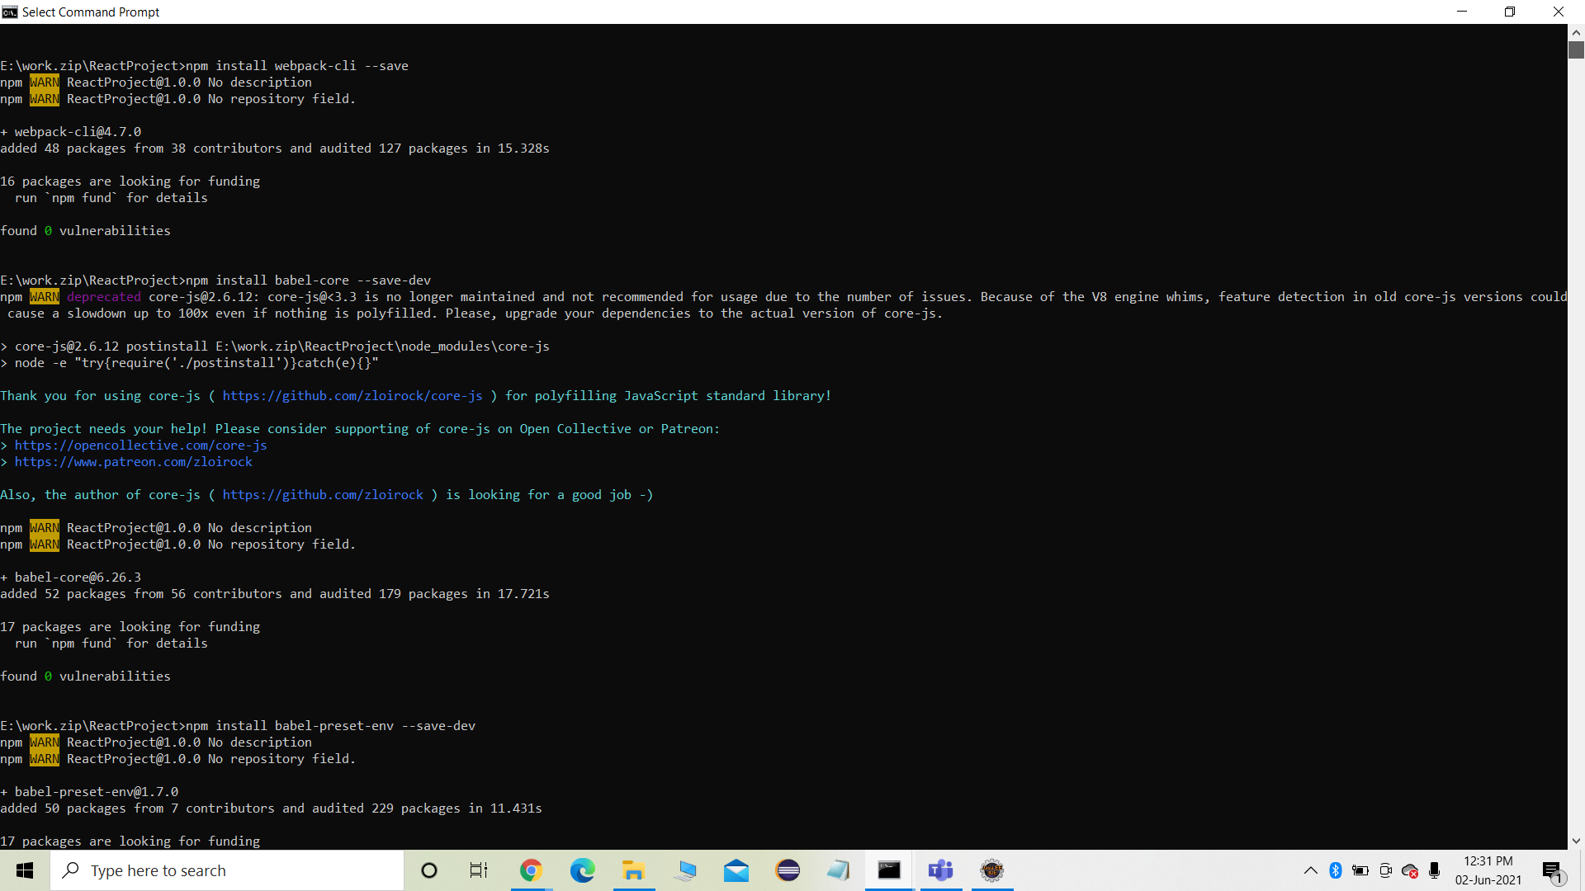

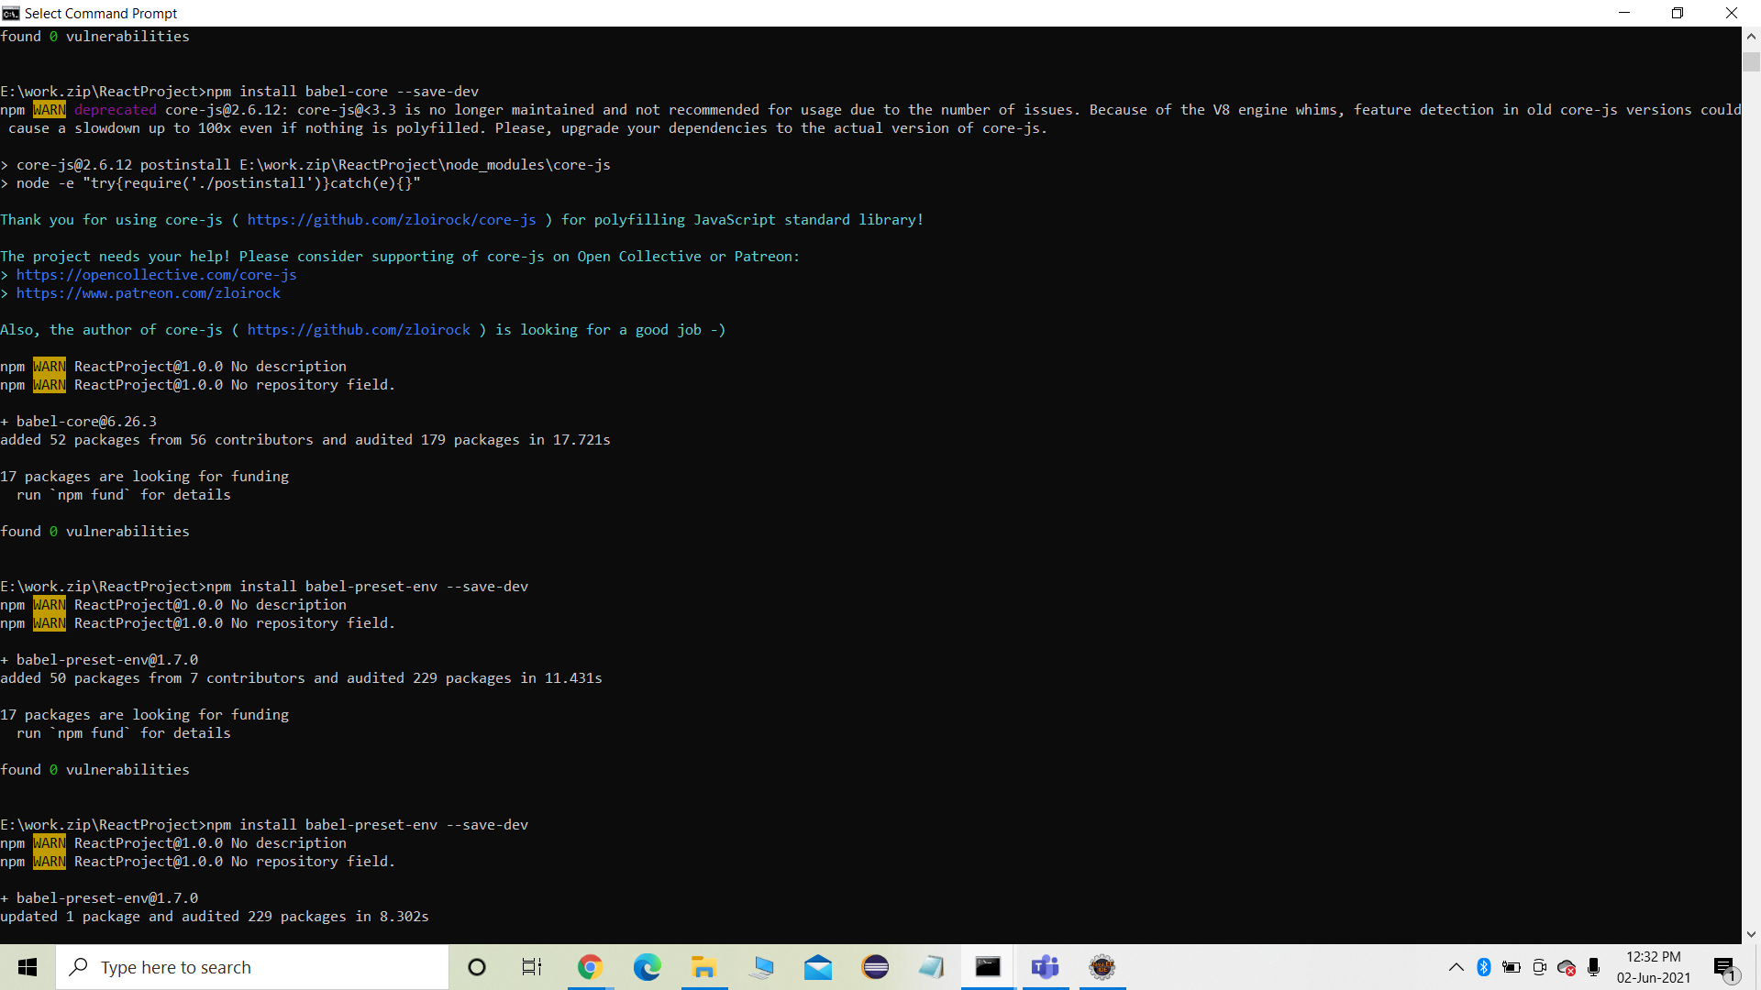

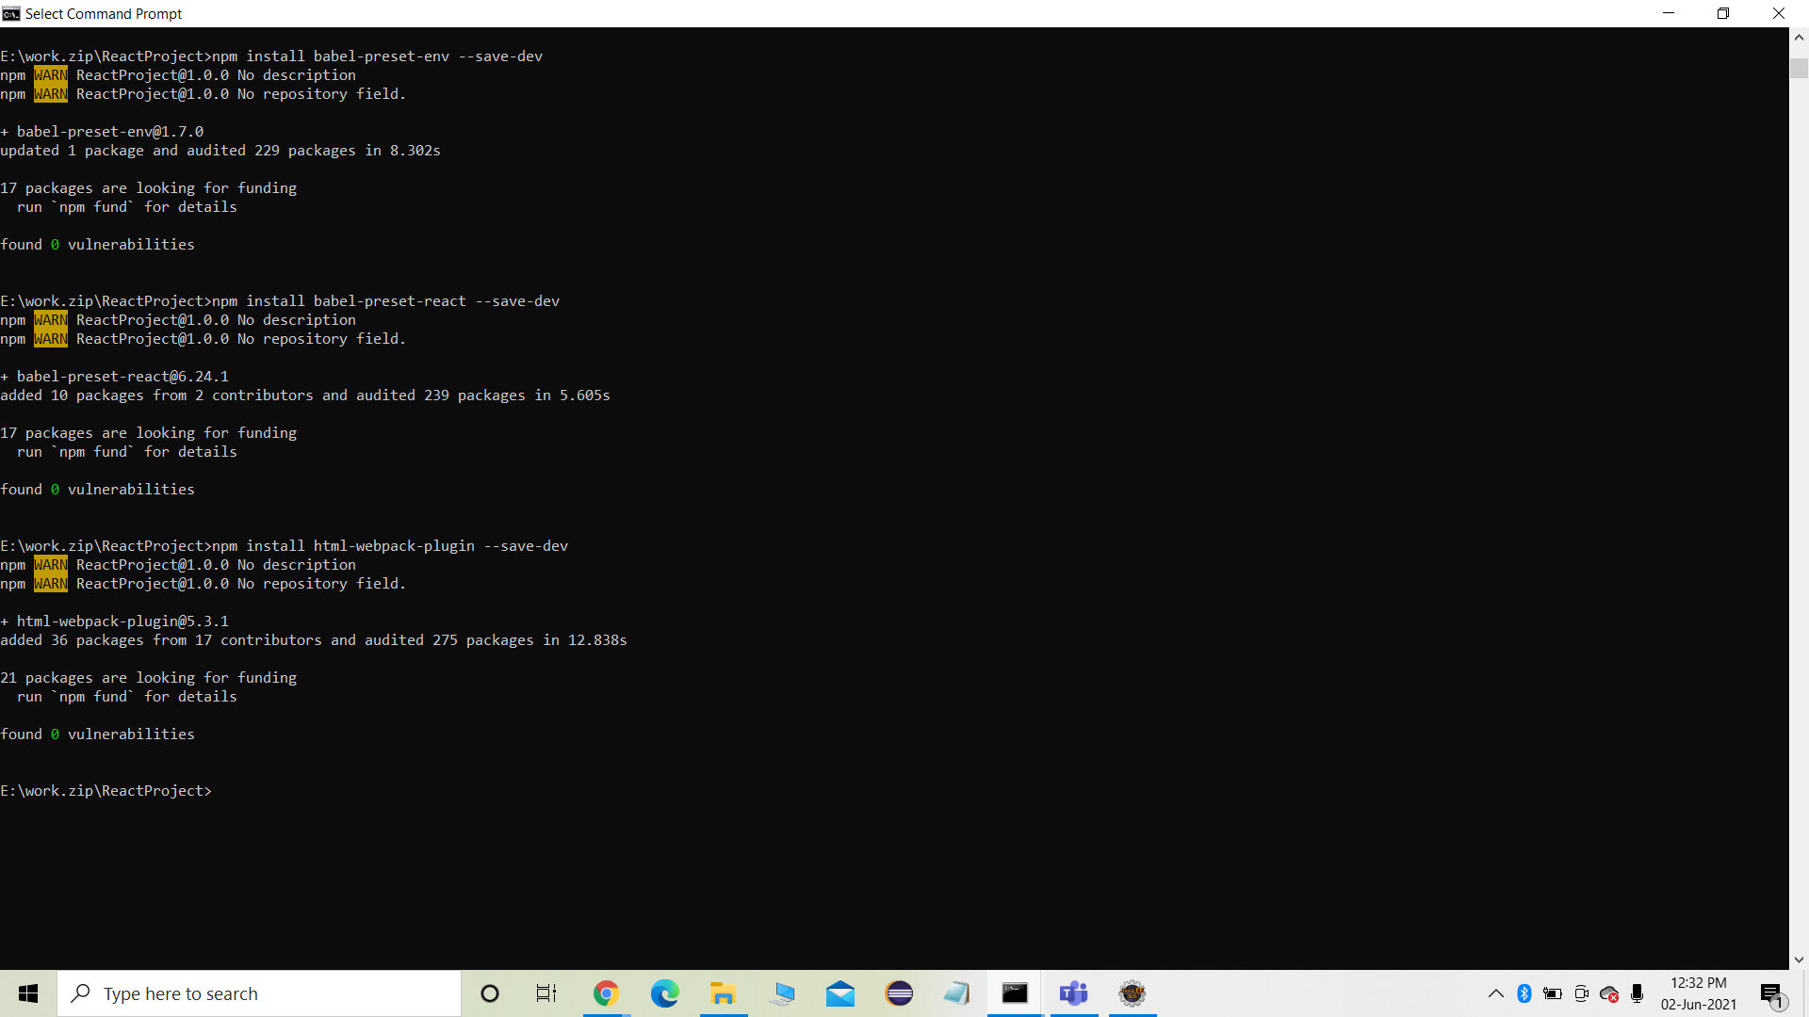

And after executing these commands in your command prompt you have to run few more commands as

C:\Users\reactApp>type nul > index.html

C:\Users\reactApp>type nul > App.js

C:\Users\reactApp>type nul > main.js

C:\Users\reactApp>type nul > webpack.config.js

C:\Users\reactApp>type nul > .babelrc

type nul > index.html

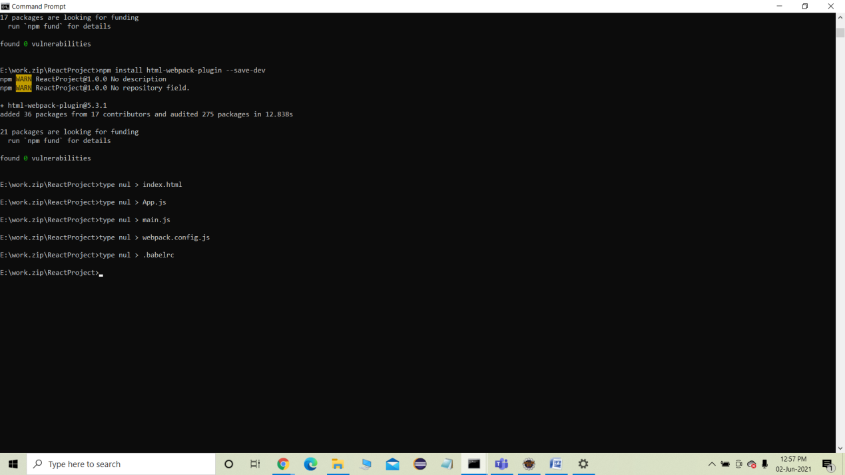

**Note:You have to type only from** type nul such as ex: type nul > index.html

After executing these commands you will get those files in the folder

You will find files in the folder as:

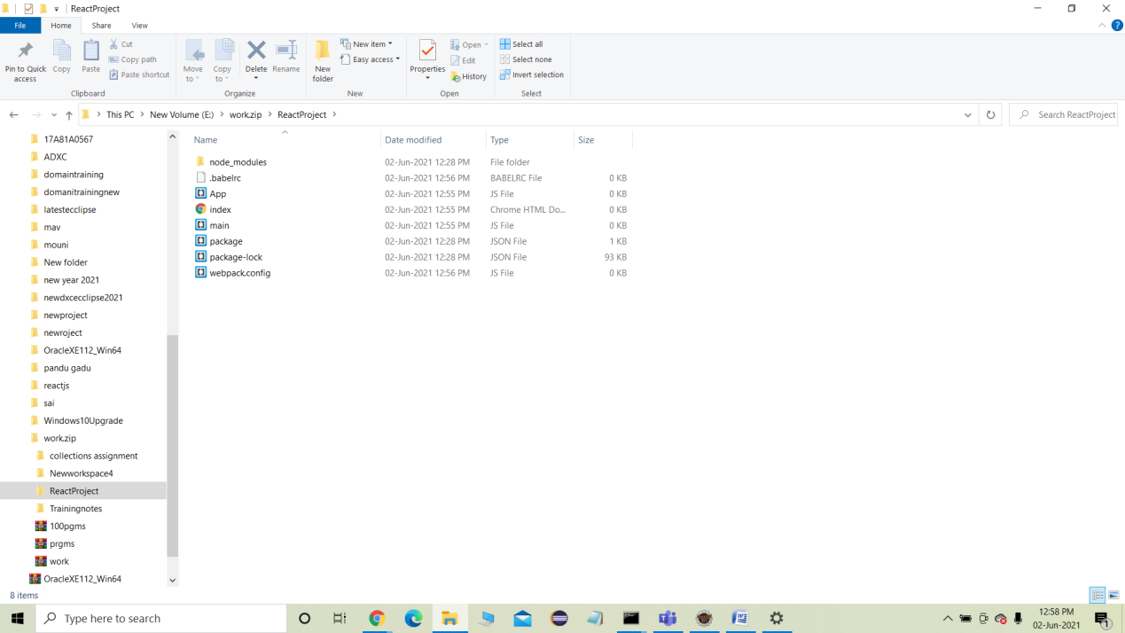

Open the editior you have such as Ex:Brackets etc… and open that created folder in brackets.

🡪And place index file code as:

<!DOCTYPE html>

<html lang = "en">

<head>

<meta charset = "UTF-8">

<title>React App</title>

</head>

<body>

<div id = "app"></div>

<script src = 'index_bundle.js'></script>

</body>

</html>

-->Webpack code :

const path = require('path');

const HtmlWebpackPlugin = require('html-webpack-plugin');

module.exports = {

entry: './main.js',

output: {

path: path.join(__dirname, '/bundle'),

filename: 'index_bundle.js'

},

devServer: {

inline: true,

port: 8001

},

module: {

rules: [

{

test: /\.jsx?$/,

exclude: /node_modules/,

loader: 'babel-loader',

query: {

presets: ['es2015', 'react']

}

}

]

},

plugins:[

new HtmlWebpackPlugin({

template: './index.html'

})

]

}

->> app.jsfile code:

import React, { Component } from 'react';

class App extends Component{

render(){

return(

<div>

<h1>Hello World</h1>

</div>

);

}

}

export default App;

->main.html code:

import React from 'react';

import ReactDOM from 'react-dom';

import App from './App.js';

ReactDOM.render(<App />, document.getElementById('app'));

Next

Run In comnd prmt as: npm start:dev.

Output when typing localhost:3000 in browser will give as:

